**Priya Khadke Lab1 Report**

**Part 1: Calculator**

Client : The Calculator app will accept the client input using below seen client UI.

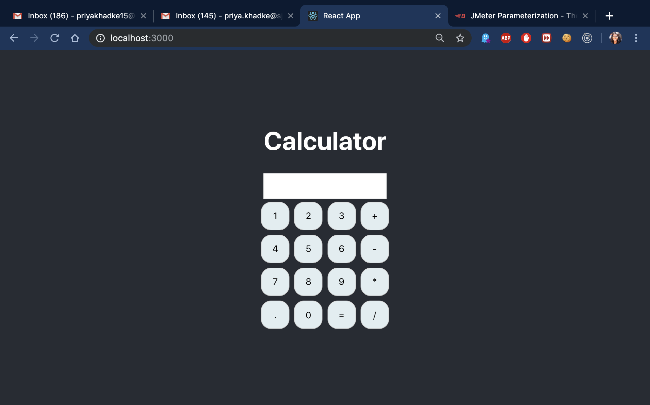

Server: The backend of calculator can process the calculations including Addition, Subtraction, Multiplication and Division.

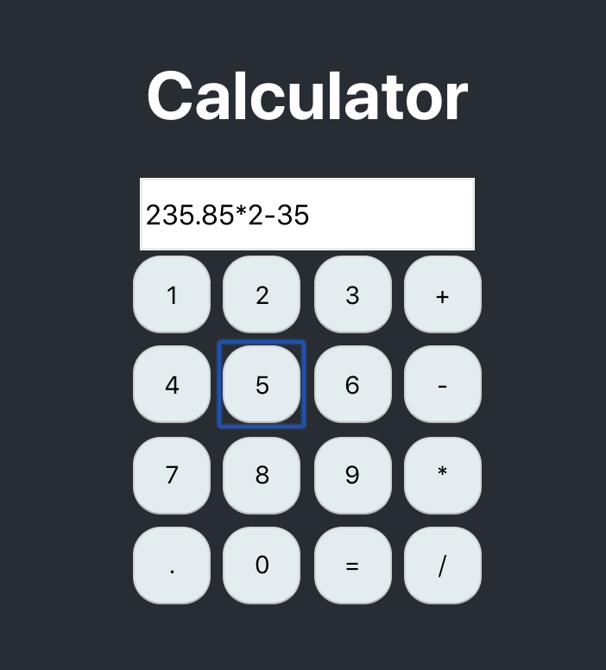

Input

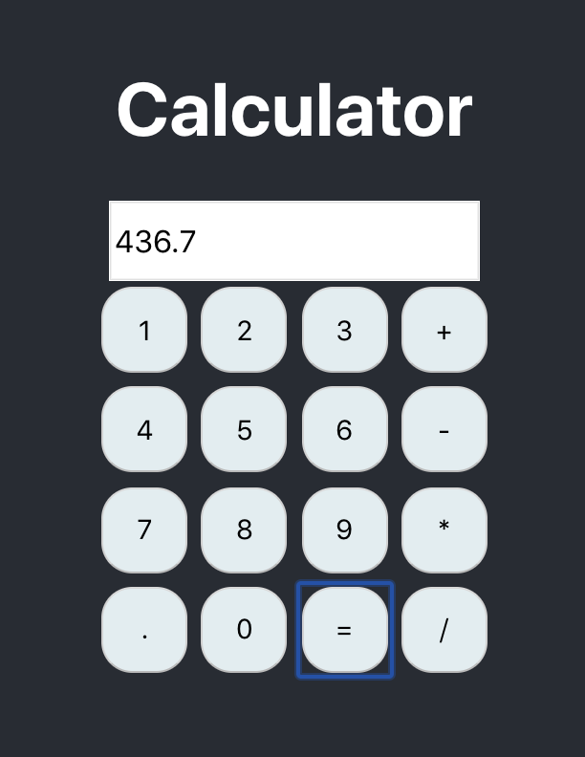

Output

**JMeter Testing:**

The calculator application was tested using JMeter load testing tool with below 3 tests. The results are discussed in detailed for each.

1. Invoke 1,000 calculator calls on randomly selected tasks.
2. Invoke 5,000 calculator calls on randomly selected tasks.
3. Invoke 100 concurrent users with 1000 calls each to calculator on randomly selected tasks.

**Test 1 : 1000 Calculator calls**

**Test Settings : 1000 request to calculate a set of 10 different arithmetic expressions. These 1000 threads would ramp up in 20 sec ( 50 threads in 1 sec ).Each of the 1000 users will repeat only once.**

**Test Parameter File: The set of test data was provided using csv file with set of 10 test data.**

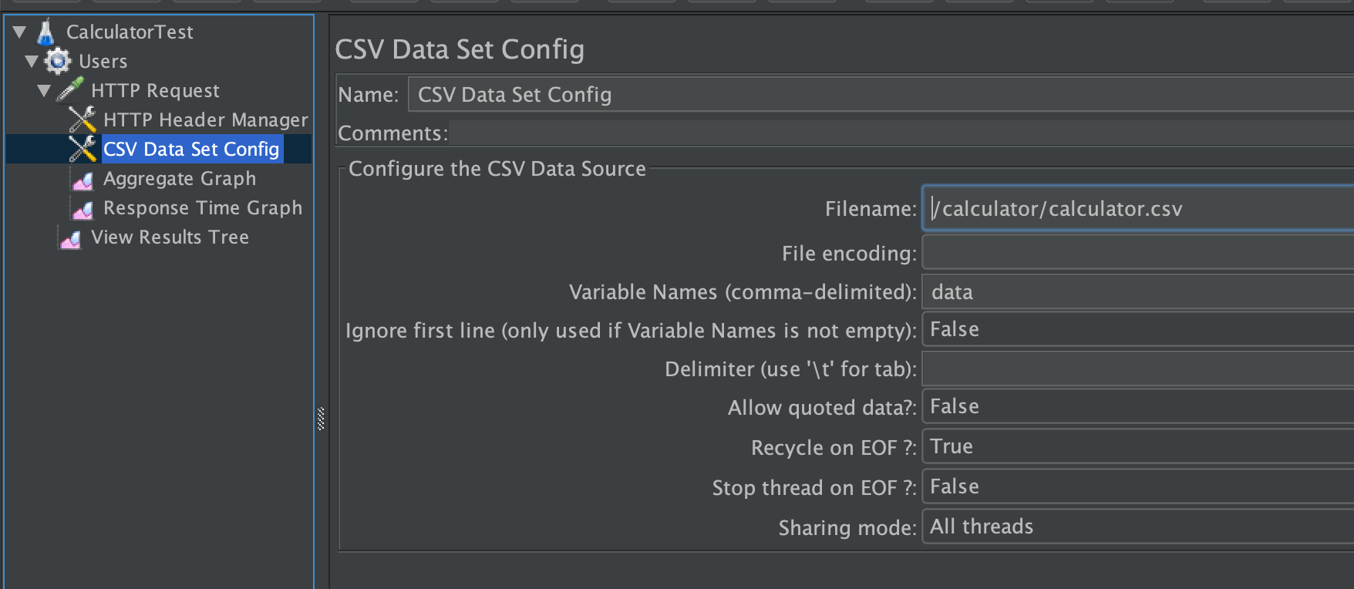

**CSV File with Test Data**

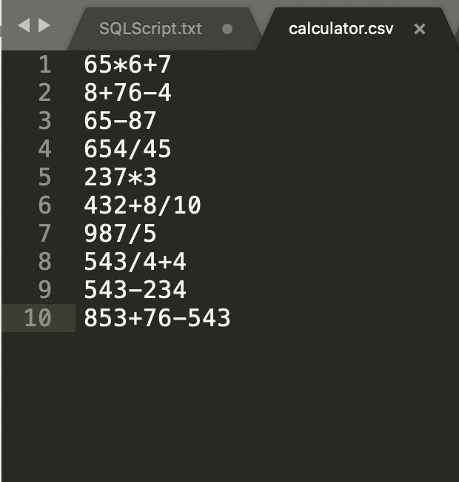

**Add HTTP Headers: Add header Content-Type for the /calculate api POST request**

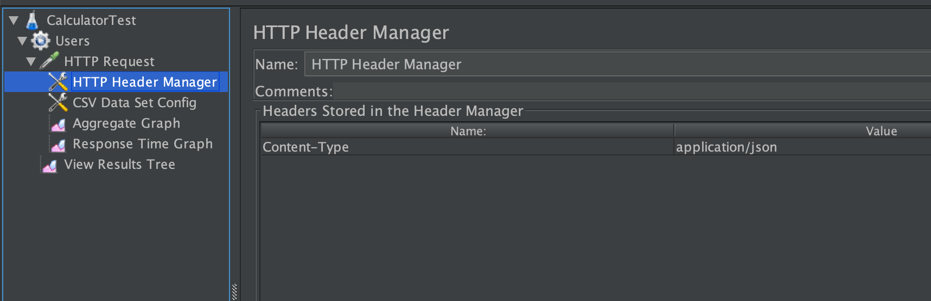

**HTTP Post Request to simulate load:**

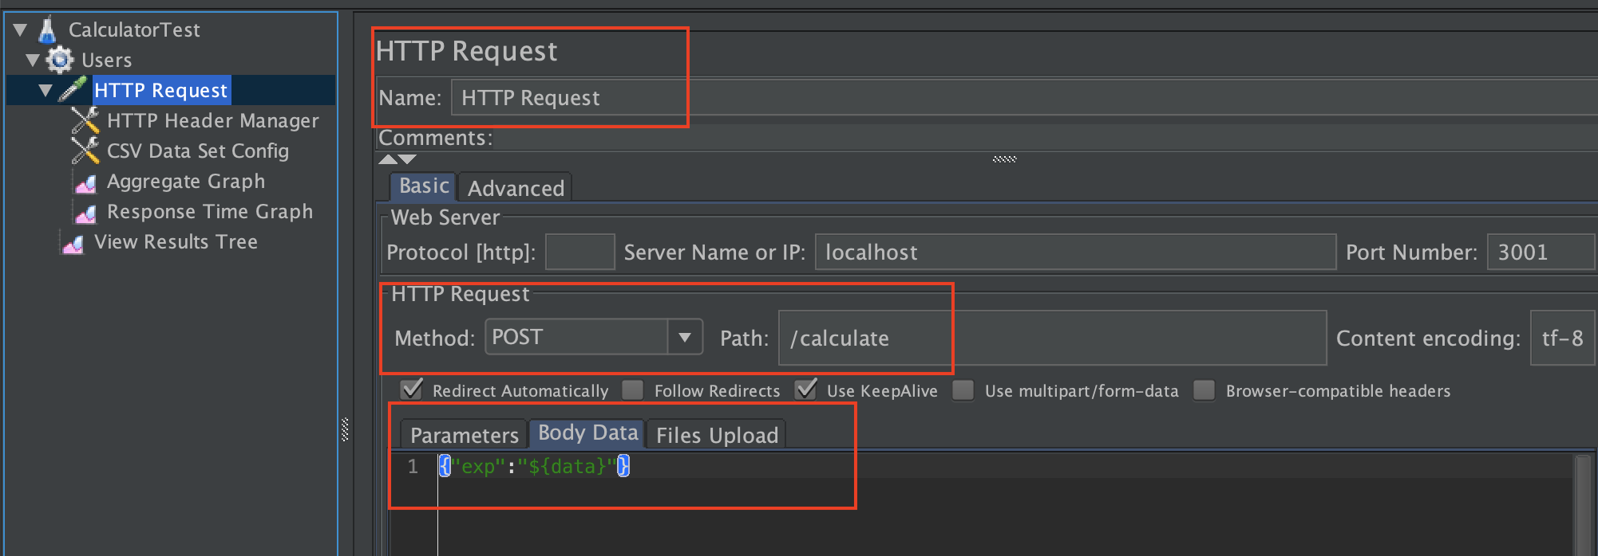

**Test Results**

**Average Response Time Graph for /calculate request**

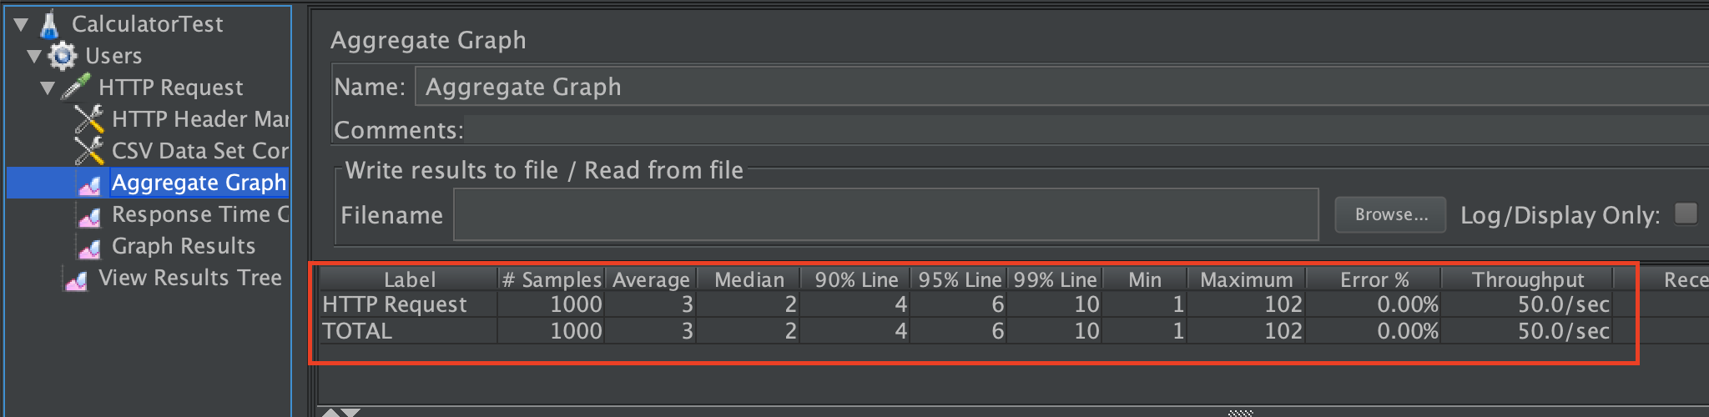

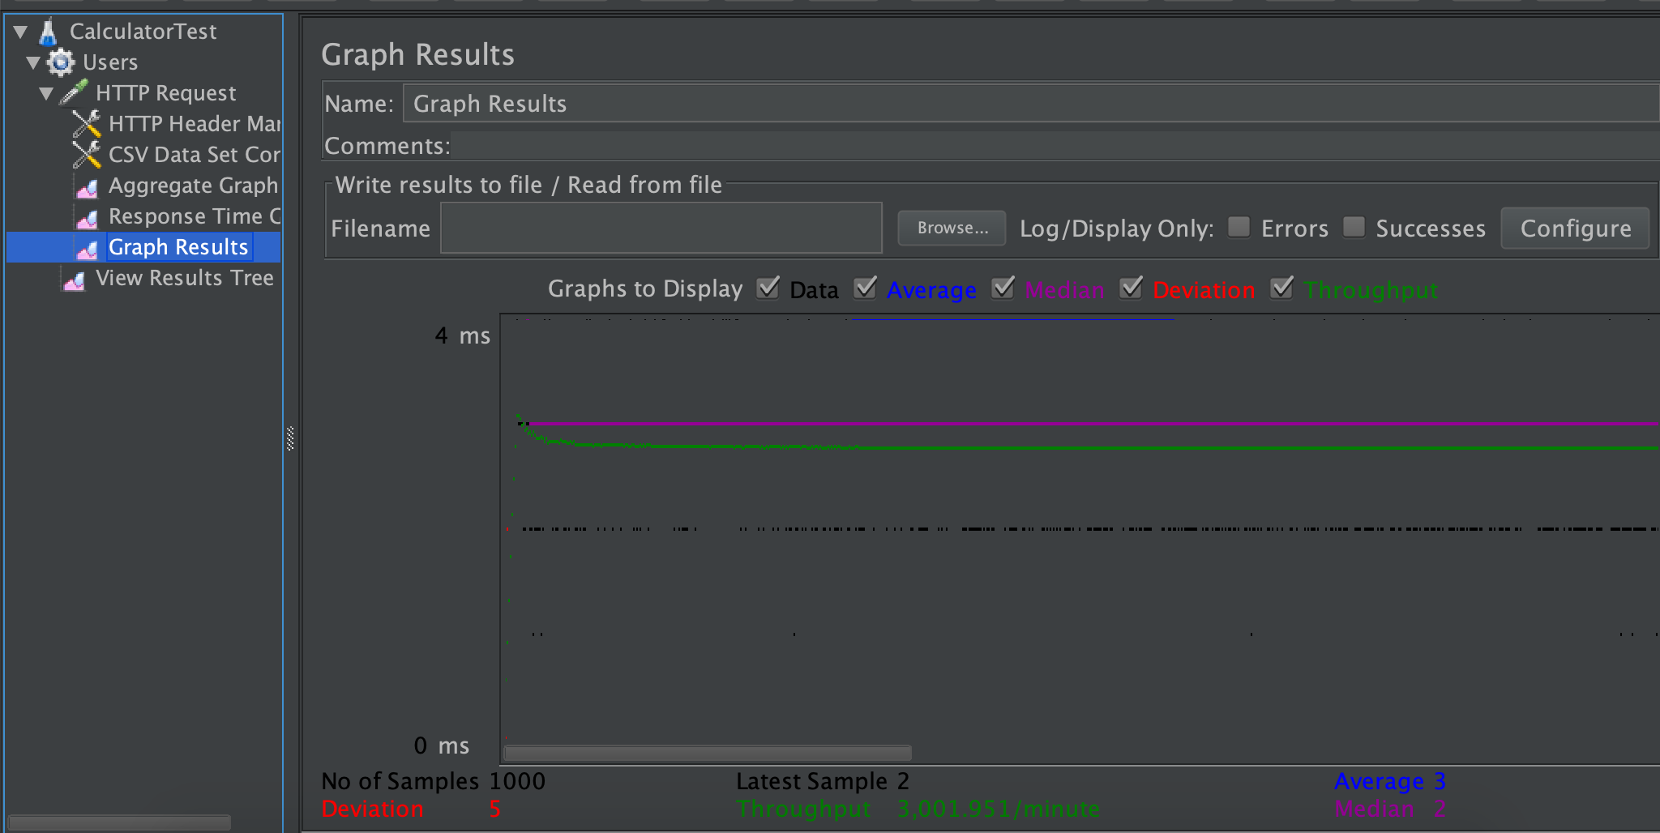

**Test 2 : 5000 calls on calculator**

**Due to limitations on local machine , the 5K threads test was executed on non-GUI mode.**

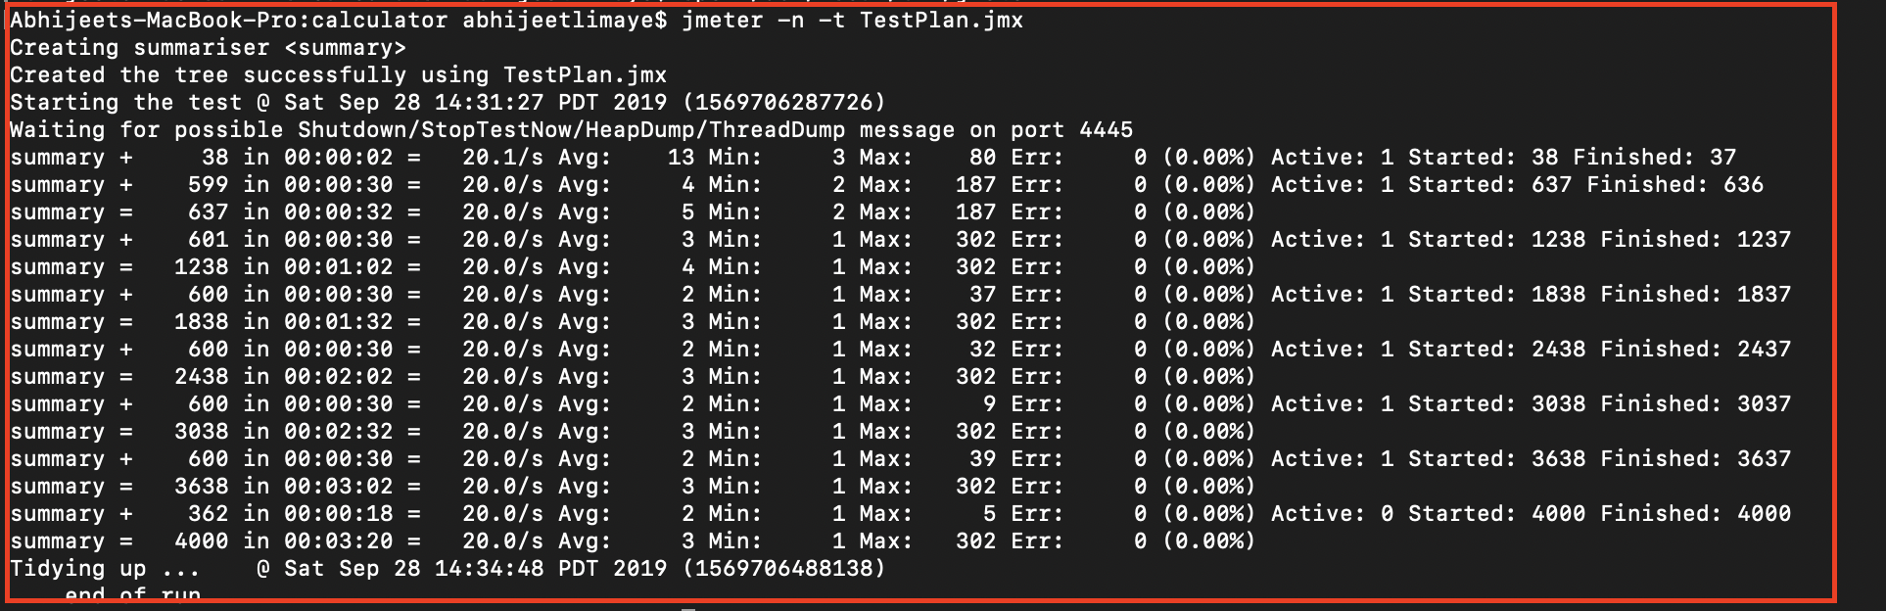

**Key Observations :**

**Part 2 : GrubHub**

**Questions**